

**Batch: B-1 Roll No.: 16010422234 Name: Chandana Ramesh Galgali**

**Experiment No.: 4**

**Aim:** Design and Implement Magnitude Comparator. **___________________________________________________________________**

**Resources needed:** Simulation Platform, Kit

**Theory:**

**Introduction**

A magnitude digital comparator is a combinational circuit that compares two digital or binary numbers in order to find out whether one binary number is equal, less than or greater than the other binary number. We logically design a circuit for which we will have two inputs one for A and other for B and have three output terminals, one for A > B condition, one for A = B condition and one for A < B condition.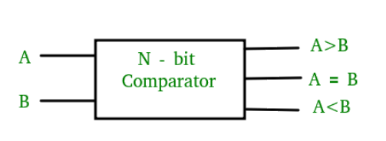

Figure-1: Block Diagram of Comparator

1-Bit Magnitude Comparator: A comparator used to compare two bits is called a single bit comparator. It consists of two inputs each for two single bit numbers and three outputs to generate less than, equal to and greater than between two binary numbers. The truth table for a 1-bit comparator is given below:

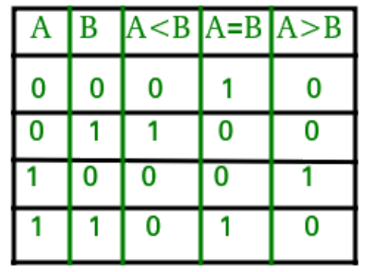

Figure-2: Truth Table of 1-Bit Comparator

From the above truth table logical expressions for each output can be expressed as follows:

A > B : AB'

A < B : A'B

A = B : A'B' + AB

By using these Boolean expressions, we can implement a logic circuit for this comparator as given below :

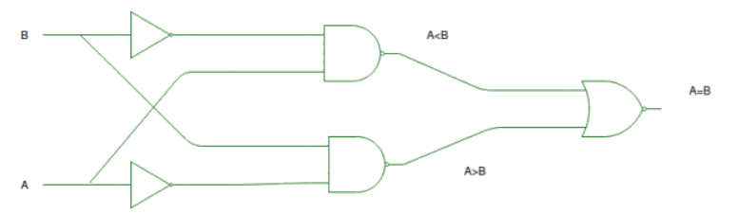

Figure-3: Logic Circuit of 1-Bit Comparator

**2-Bit Magnitude Comparator**: A comparator used to compare two binary numbers each of two bits is called a 2-bit magnitude comparator. It consists of four inputs and three outputs to generate less than, equal to and greater than between two binary numbers.

**Procedure:**

1. Design a 2 bit Magnitude comparator
2. Explore the datasheet of IC 7485( link in references)
3. Design 4 bit comparator using IC 7485.
4. Implement and verify the same using Hardware kit/simulation software.
5. Create a document with screenshots mentioned above, Outcome and Conclusion.
6. Please note every document uploaded as Lab Write-up should be labelled as Exp_<No>_<RollNo.pdf

**___________________________________________________________________________**

**Observations and Results:**

1. Design of Magnitude Comparator.

2 bit Magnitude comparator

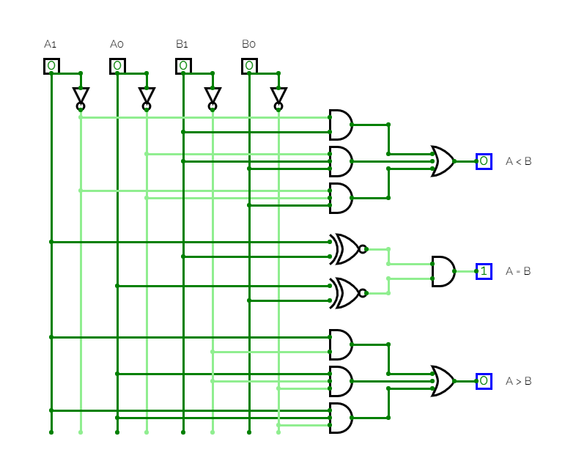

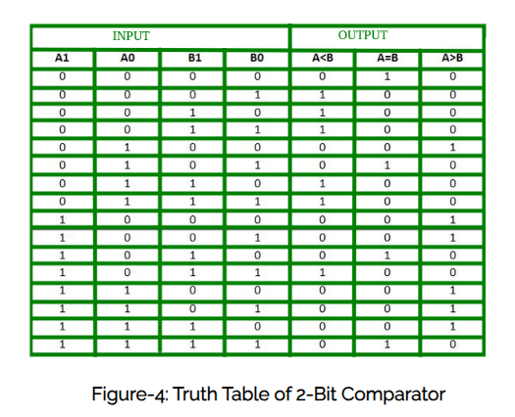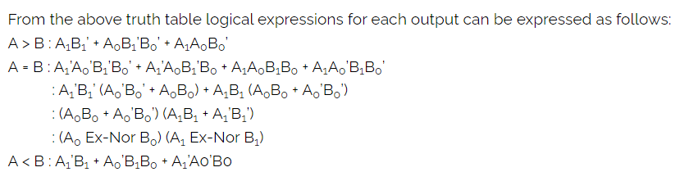

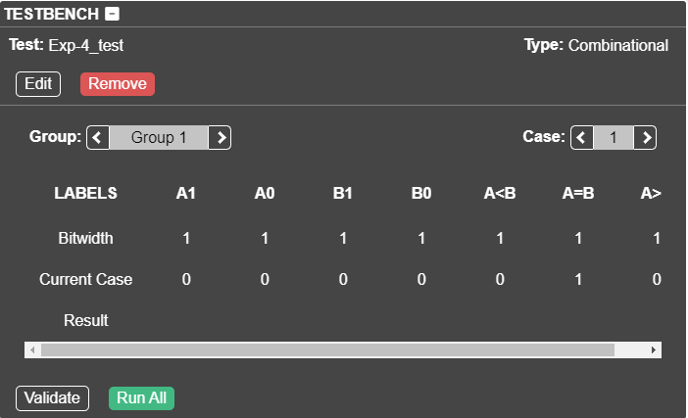

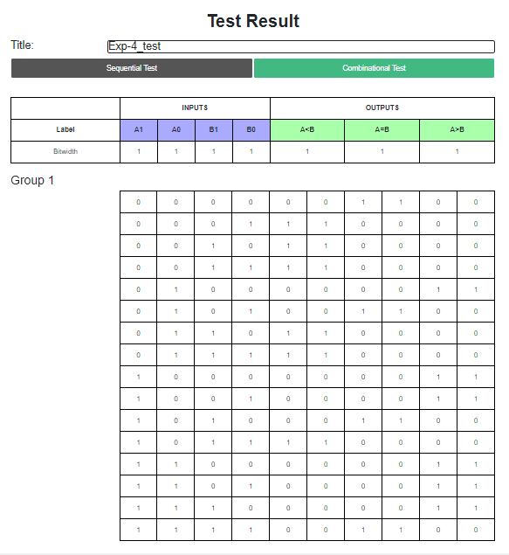

4 bit Magnitude comparator

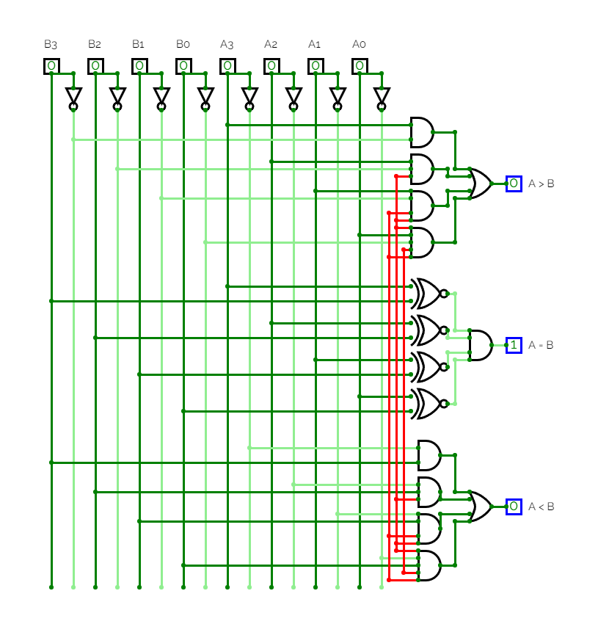

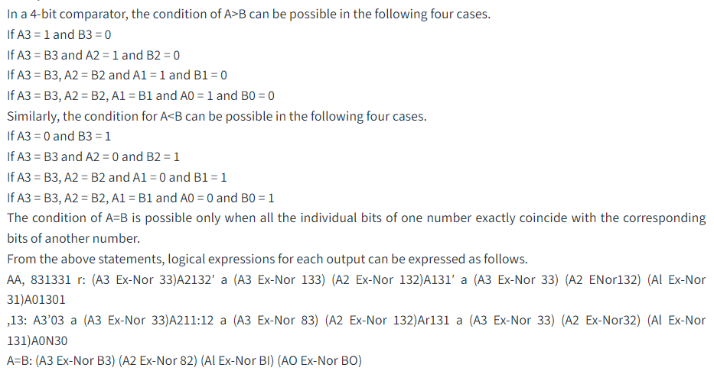

1. Observe and understand the simulated/implemented logical circuits.

**Outcomes:** Understand the basic building blocks, techniques used in digital logic design.

**Posttest:**

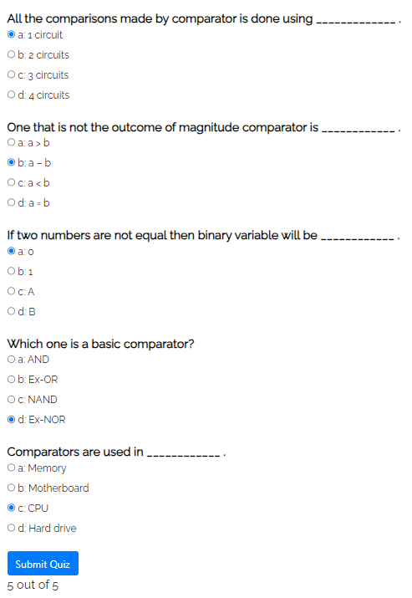**___________________________________________________________________________**

**Conclusion:**

In this experiment, we successfully designed and implemented both 2-bit and 4-bit magnitude comparators using CircuitVerse. The purpose of the experiment was to compare the magnitudes of two binary numbers and determine their relationship (greater than, less than, or equal).

**Grade: AA / AB / BB / BC / CC / CD /DD**

**Signature of faculty in-charge with date**

**___________________________________________________________________________**

**References:**

**Books/ Journals/ Websites:**

1. R. P. Jain, “Modern Digital Electronics”, Tata McGraw Hill.
2. <https://de-iitr.vlabs.ac.in/exp/comparator-using-logic-gates/theory.html>
3. <https://pdf1.alldatasheet.com/datasheet-pdf/view/8074/NSC/7485.html>